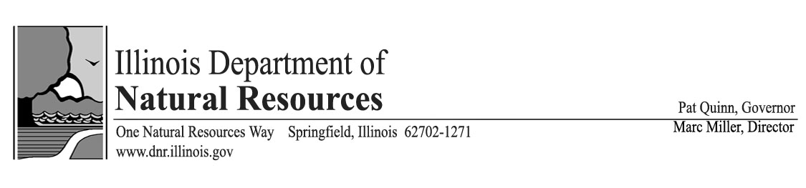
Vote YES on SB 1566 (Mautino/Hutchinson) – IDNR Sustainable Funding

- Critical sustainability package for IDNR that was previously HB 4193.

- Allows IDNR to continue to protect our natural resources, support economic development, and provide for the public safety.

- Generates $32 million in new, sustainable revenues for IDNR that cannot be swept.

- All fees in this agreed to bill will be protected by NO SWEEPS language.

Without SB 1566:

- massive reductions in state parks services;

- inability to respond to natural disasters and save lives because of dangerously aged and inadequate boats, trucks, and other equipment;

- extreme delays in permitting economic development projects that create new jobs;

- substantially increased delays in the review and awarding of grants;

- insufficient staff to allocate water to over 7 million residents in northeastern Illinois; and

- severely curtailing, if not terminating, other services IDNR now provides.

SB 1566 is supported by: Illinois Association of Park Districts, Illinois Oil and Gas Association, Illinois Coal Association, Illinois Environmental Council, Sierra Club, Chicago Wilderness, Audubon Chicago Region, Environmental Law and Policy Center, The Nature Conservancy, Openlands, Trust for Public Land, Prairie Rivers Network, Trails for Illinois, Faith in Place, Partners for Parks and Wildlife, League of Illinois Bicyclists, Illinois Horsemen’s Council, Illinois Paddling Council, ABATE, Ducks Unlimited, National Wild Turkey Federation, Illinois Federation for Outdoor Resources, Pheasants Forever, Quail Forever, Illinois Smallmouth Alliance, Migratory Waterfowl, Bird Conservation Network, Lake County Forest Preserve District, The Land Conservancy of McHenry County, Illinois Association of Forest Preserve and Conservation Districts, the Wildlife Society (Illinois Chapter)
Vote YES on SB 1566 (Mautino/Hutchinson) – IDNR Sustainable Funding

Sustainability concepts in SB 1566

- To support the state parks system, assess a $2 surcharge on motor vehicle registrations of passenger cars and trucks, motorcycles, motor driven cycles and pedalcycles. The fee will support the state parks system’s operational and maintenance needs, including road and facility construction. There will be a fee to non-residents who use our state parks and other sites. With SB 1566, there is no site entrance fee for Illinois residents.

- Assess a consultation fee to support IDNR’s consultation services performed for state and local governments under the Illinois Endangered Species Protection Act and Illinois Natural Areas Preservation Act. IDNR receives an average of 5,000 consultation requests each year which are an essential part of economic development.

- Charge an application fee to entities applying for IDNR-administered capital grants. The modest fee will support the Grants staff. OSLAD is exempt.

- Cost recovery for National Heritage Database access, maintenance, and expansion. The single most complete source of information about rare, threatened, and endangered species in the State of Illinois, the Natural Heritage Database is a valuable and highly sought-after resource, especially with the increase in large wind and energy projects.

- Assess a fee per application for permits issued under the Rivers, Lakes, and Streams Act. The Office of Water Resources reviewed and processed 1,118 highly technical permit applications in the previous five years. Delays in review and processing prevent projects from moving forward and inhibit economic development.

- Establish an Off-Highway Vehicle (OHV) Usage Stamp in lieu of OHV registration.

- Charge an Illinois State Museum entrance fee.

- Charge fees to use a public beach, bike trail, and equestrian trail.

- To support the Office of Mines and Minerals, implement a permit revision fee and a fee structure for title-specific certifications in the coal mining industry; increase certain operating and reclamation fees paid by the aggregate mining industry; and increase or establish oil and gas well permit and assessment fees.

- Increase certain non-resident and commercial fishing fees. The resident sport fishing license fee will not increase.

- Increase fees and extend license/permit expiration dates for a falconry license, captive propagation permit, and raptor capture permit. These changes are consistent with new federal regulations regarding the expiration date of these licenses and permits.

- Assess a fee for a scientific or special purpose permit.

- Presently, $2 from the fee collected for each certificate of title, duplicate certificate of title, and corrected certificate of title is deposited in the Park and Conservation Fund to support development of bike trails. IDNR proposes an increase from $2 to $3.25.

- Establish the Illinois Fisheries Management Fund and direct 20% of the revenue IDNR receives from vehicle titling fees (certificate of title, duplicate certificate of titles, and corrected certificate of title) to this fund.

- Increase registration fees on motorized watercraft. Additionally, replace registration of canoes and kayaks with a Paddle Pass. The Paddle Pass is an annual stamp to use a “non-powered watercraft” in the State of Illinois.
Support IDNR and Vote YES on SB 1566

